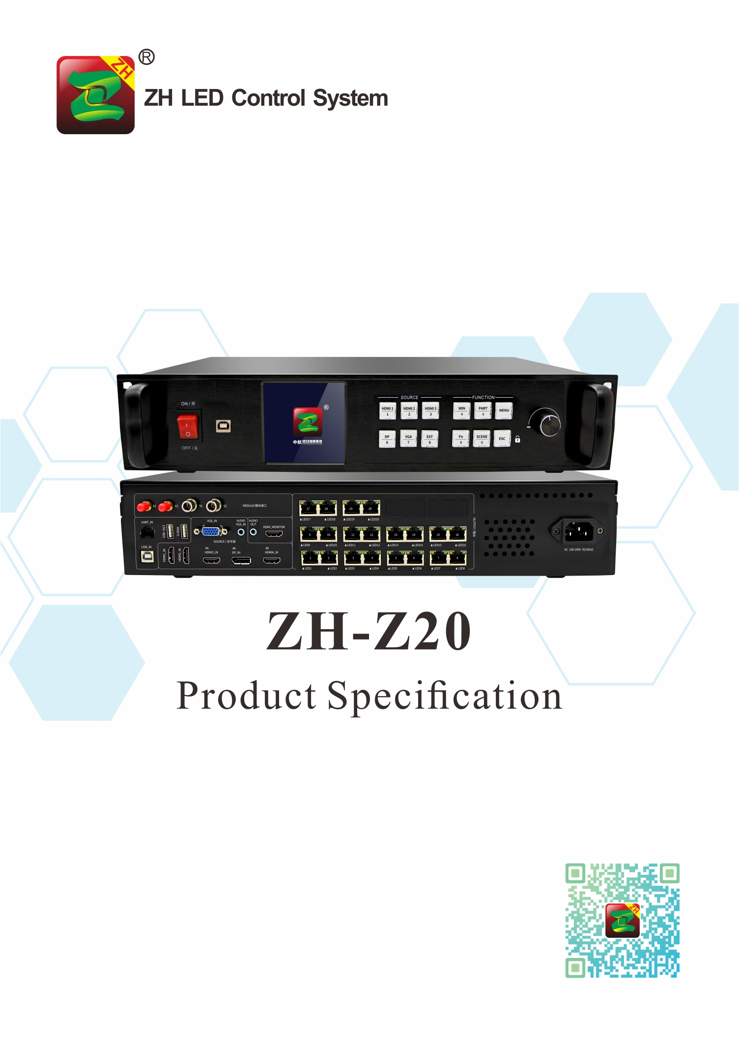

Product Specification
ZH-Z20
I. Product Introduction:
The ZH-Z20 two-in-one multi-window video player is a product produced by ZH to meet the convenience of large LED screen installation. It supports HDMI, DP and other high-definition signal input; can receive up to 4096*2160@60Hz pixel high-definition digital signal, 20 PCS Gigabit Ethernet port output, single device supports pixels: Max width 16384,or Max Height 4096. Adopt a new communication architecture, high refresh, high brightness, new grayscale scanning engine, nanosecond synchronization, and communication can be maintained smoothly under bad communication conditions, allowing users to experience a more colorful and better LED world!
II. Functional Features：
- Input interfaces, 2pcs HDMI 2.0, 2pcs 1.4, 1pcs DP, 1pcs VGA;
- Input resolution: Max pixel is 4096*2160@60Hz,supports arbitrary setting of resolution;
- Single card Max loading: 13 million points, Max Width 16384, Max Height: 4096;
- Support arbitrary switching of video sources, splicing and zooming input images according to the resolution of the display screen;
- Support four windows roaming freely;
- Support audio input and output;
- Support brightness and color temperature adjustment
- 20 PCS Gigabit Ethernet port output, support arbitrary splicing up and down, left and right;
- Support hot backup: two network ports in the same group for hot backup and multi-card hot backup;
- Support low brightness and high gray;
- Support ZH full series of receiving cards, multi-function cards, and fiber optic transceivers;

III. Topology Diagram:

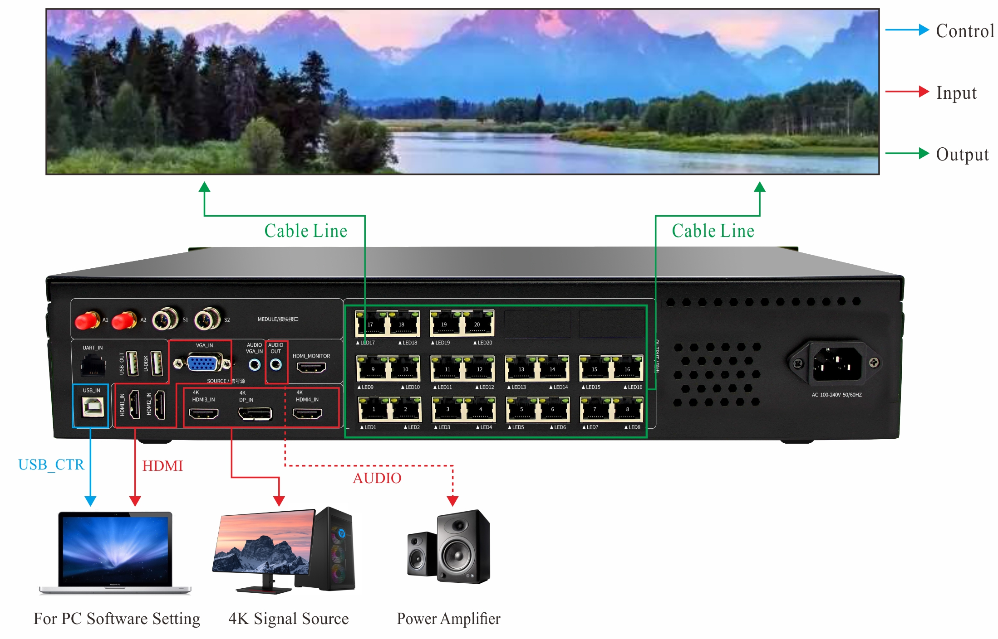

IV. Hardware Introduction:
The Front Panel
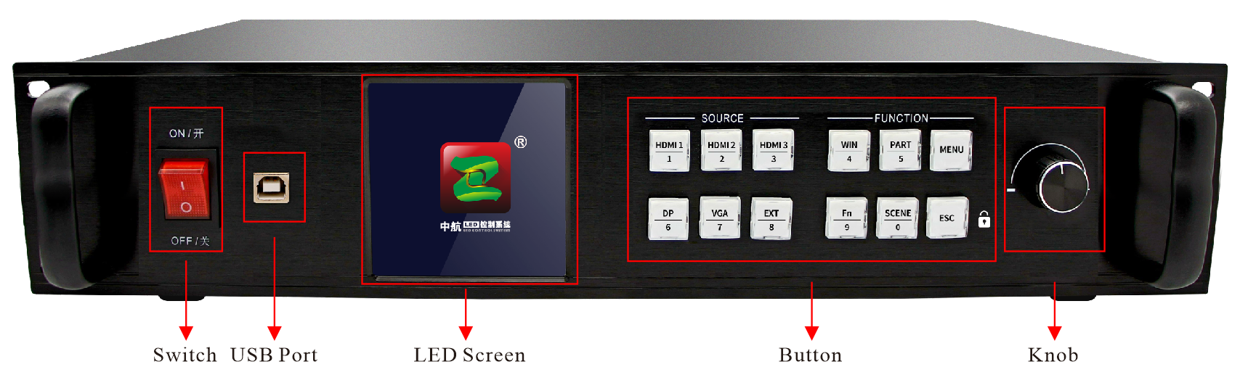

Switch | The power switch
USB Port | PC software setting port
LCD | Displays detailed prompts for user
Knob | Adjust the LED screen resolution and confirm

Button Part Manual
SOURCE |  | FUNCTION
HDMI/1 | HDMI 1/number 1 | WIN/4 | Multi-window settings/number 4
HDMI/2 | HDMI 2/number 2 | PART/5 | Partial and Full switch/number 5
HDMI/3 | HDMI 3/number 3 | MENU | Enter the menu advanced setting mode
DP/6 | DP/number 6 | FN/9 | Compound key/number 9
VGA/7 | VGA/number 7 | SCENE/0 | Scene shortcut key/number 0
EXT/8 | EXT/number 8 | ESC | Back

The Back Panel
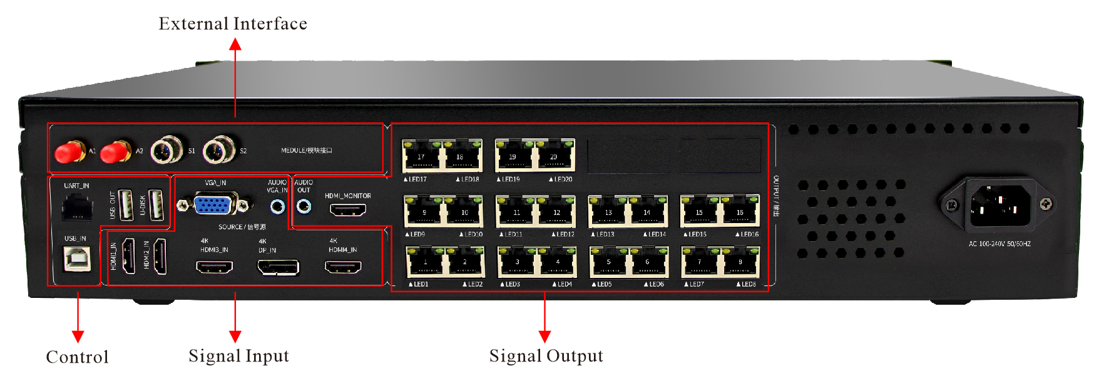

CONFIG |  | Single Input |  | Single Output
USB_IN | System setting | HDMI_IN*4 | HDMI input | LED*20 | Output LAN port 1--20
USB_OUT | Device cascade debugging interface | DP_IN 4K | DP input | AUDIO_OUT | Audio port
U-DISK | Update port | VGA_IN | DP input
UART_IN | Intelligent console interface | AUDIO VGA_IN | VGA Audio input
External Interface
A1，A2 | Antenna port
S1，S2 | Sensor (operational)

Input:

Port | Quantity | Resolution
HDMI 1.4 | 2 | Stander EIA/CEA-861
HDMI 2.0 | 2 | Stander EIA/CEA-861, match HDMI-2.0 stander, support HDCP2.2
VGA | 1 | Support 1920*1200/60Hz and so on, match VESA stander resolution
DP | 1 | Match DP-1.2 stander, support HDCP1.3
AUDIO | 1 | 3.5mm stander audio input port
USB | 1 | Standard USB 2.0port

Port | Quantity | Resolution
LED | 20 | Standard Gigabit Ethernet port, support ZH V5 all types of receiving cards, support arbitrary splicing up and down or left and right
AUDIO | 1 | 3.5mm standard audio output port
Output:

Chassis parameters:
Power Input | AC 100~240V，50/60Hz,not more than 1A
Temperature | -20~45℃
Size | 482*281.5*66.5(mm,L*W*H)
Weight | 6.5KG

VI. Hardware Diagram:
Unit: mm

